**COMET BAY COLLEGE**

**Physics Unit 3 - Task 6**

**Electromagnetism Test 2**

**Name: Total Marks /56**

**Question 1**

The diagram below shows an AC generator consisting of a rectangular coil with dimensions of

14.0 cm × 21.0 cm, and 800 turns of copper wire. The magnetic flux density between the poles is 9.40 mT. The coil is turned at a uniform rate.

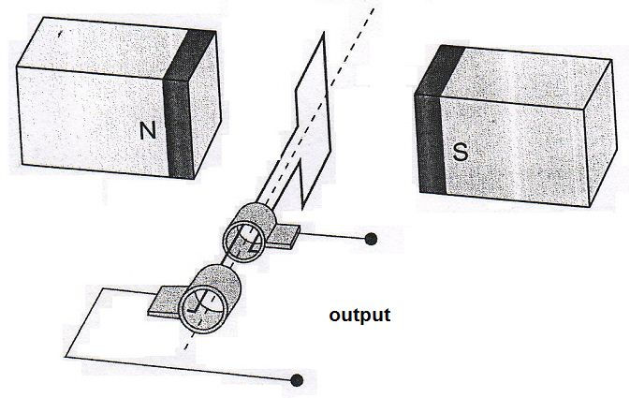

**SR**

**B**

**B**

1. Referring to Lenz’s law, explain how induced emf is achieved from such a generator and why the output is a sine or cosine shape rather than being constant. (3 marks)
2. The coil is rotated at 1500 rpm. Calculate the magnitude of the average induced emf in the coil as it rotates through 90º from the position shown. (3 marks)
3. Sketch the emf output curve for this AC generator on the graph below. You must start from the position shown on the diagram and continue up to 80 ms. Make estimates for values that you cannot calculate. (3 marks)



1. Indicate three times on the graph when the flux enclosed by the coil is a maximum value at 1500 rpm. **Circle** these times. (1 mark)
2. When the coil is rotated at 750 rpm the emf output changes. Sketch a second voltage curve onto the graph and clearly label it ‘750 rpm curve’. (1 mark)

**Question 2**

🞫 🞫 🞫 🞫

🞫 🞫 🞫 🞫

🞫 🞫 🞫 🞫

🞫 🞫 🞫 🞫

🞫 🞫 🞫 🞫

Rail falling at 25.0 m/s within magnetic field

An iron rail of mass 150 kg and length 4.22 m is falling at 25.0 m s-1 next to a magnetic pole of a large electro-magnet in a breakers yard. The magnetic flux density of the electro-magnet is 840 mT and its direction is indicated in the diagram.

1. Calculate the potential difference across the length of the rail. (2 marks)
2. Explain, referring to charge location, how a potential difference is established in this situation. (2 marks)

**Question 3**

The figure below represents a DC motor whose coil is initially stationary.

* JK = LM = 16.0 cm KL = JM = 12.0 cm
* The coil has 120 turns of wire
* The uniform magnetic flux density between the poles = 95.0 mT
* The current in the coil is 6.30 A when the motor is switched on and it turns clockwise.



a) In which direction, clockwise or anticlockwise will the motor rotate when the switch is closed? (1 mark)

b) Explain your answer to part (a). (2 marks)

1. Indicate the positive and negative terminals on the DC power supply for this direction of rotation. (1 mark)
2. Calculate the force acting on side LM of the coil when the switch is closed. (2 marks)
3. Calculate the maximum torque that this motor can produce. (2 marks)

**Question 4**

A teacher set up a model to demonstrate how electricity is distributed using a power supply, transmission wires, meters and a transformer. A diagram of the model is shown below. Resistance in the wires connecting the **power supply, transformer and globe** to the transmission lines can be ignored.



The transformer is ideal (100% efficient) and the ratio of primary to secondary windings is 5:1.

* 1. If the current through ammeter A1 is 0.5 A, calculate the following:

1. The reading on ammeter A2 (2 marks)
2. The reading on voltmeter V1 (2 marks)
3. The reading on voltmeter V2 (2 marks)

b) If the AC power supply is replaced by a 12V battery, what will be observed at the globe? (1 mark)

c) Explain your answer to (4c) in terms of the operation of the transformer. (2 marks)

1. In the real world electric power is distributed over large distances at high voltages. Explain why. (2 marks)

**Question 5**

A light globe that is plugged into the mains electricity supply of an Australian house is actually switching on and off 100 times per second. This is because the mains electricity is powered by Alternating Current (AC). If current is plotted against time it is a sinusoidal wave form with a frequency of 50 Hz. The light globe will glow at its brightest when current has a maximum magnitude and will momentarily be switched off as the current changes direction.



*Graph 1 showing alternating emf in an Australian household mains supply*

Diagram 1 shows the coil PQRS of an AC generator placed between magnetic poles.

* A uniform magnetic field of flux density 0.126 T exists between the magnetic poles.
* The dimensions of the coil are: PQ = SR = 17.0 cm and PS = QR = 9.00 cm
* The coil rotates about the axle as indicated as a torque is applied to the pulley.
* The coil has 600 turns of wire and is rotated uniformly at 840 rpm.

Diagram 1 – AC generator viewed from the top. Coil PQRS sits flat in the magnetic field between the North and South magnetic poles shown.

Contacts to external circuit

Slip rings

Pulley that turns coil

Axle

**P**

**R**

**Q**

**S**

PQ rotates out of page

SR rotates into page

**S**

**N**

Diagram 2 – The AC generator viewed from the front (location of the slip rings) after coil PQRS has rotated by 20° from the position shown in Diagram 1.

**S**

**N**

Axle

1. Why does the passage state that a light globe switches on and off 100 times per second when the AC frequency is 50 Hz. (2 marks)
2. A simple AC circuit has a resistance of 4.00 Ω and is driven by an RMS voltage of 120 V. Determine the maximum current that will flow through the resistor as part of the AC cycle.

(3 marks)



At the instant shown in diagram 2, the magnitude of emf is: (**circle** a response) (1 mark)

Increasing Zero Decreasing Staying Constant

1. Explain your response to the previous question. (2 marks)
2. Consider the lengths PQ and RS in the AC generator in Diagram 1. They can each be considered as long straight conductors and the emf generated across them is a maximum when they move in a direction perpendicular to the magnetic field lines. From the starting point of derive the equation showing clear logical steps.

(3 marks)

1. Calculate the maximum emf (Vmax) for the AC generator shown in Diagrams 1 and 2.

(3 marks)

1. Determine the RMS voltage of this AC generator. (2 marks)

**Question 6**

The figure below represents an alternator consisting of a rectangular coil with sides of

0.15 m x 0.20 m and 1200 turns, rotating in a magnetic uniform field. The magnetic flux through the coil in the position shown is 2.5 x 10-4 Wb.



a) Calculate the magnitude of the magnetic field strength. (3 marks)

1. If the coil rotates half a revolution from its starting position in 0.03 s, calculate the magnitude of the average induced emf in the coil in this time. (3 marks)